World first for consumer cannabinoids as UK’s FSA releases list of permitted CBD products
London, 31 March 2022 - The UK has become the first country in the world to regulate the market for safe, orally consumed legal cannabis extracts, following the release today of the Food Standards Agency’s public list of cannabinoid (CBD) products permitted for sale to consumers. Publication of the list – a key stage on the path to full authorisation, expected in 2023 – follows two years of close co-operation between the FSA and the Association for the Cannabinoid Industry (ACI), the UK’s CBD sector trade body.

Only those CBD products featured on the list have been given the green light by the FSA to stay on the market, in line with the UK’s Novel Food requirements. Products not included must now be removed from shelves.

Steve Moore, ACI founder, commented: “The FSA public list represents a major milestone for the UK’s CBD category. It demonstrates the progress the sector has made to meet compliance requirements and creates greater regulatory certainty which, in turn, will increase levels of consumer trust, encourage investment in the sector, and promote innovation. ACI is immensely grateful for the work that our members and the FSA have put in to take this momentous step.”

CBD products on the FSA list have been undergoing assessment by the agency in a long and rigorous Novel Food process. This was open to any CBD product designed for oral consumption that was on sale in the UK on or before 13 February 2020, with the deadline for applications set at 31 March 2021. Any product launched after 13 February 2020, or which was not the subject of a dossier submitted by the cut-off date, may not now be sold until full authorisation is granted.

ACI has spearheaded the CBD industry’s response to the application process from the outset. In September 2020, it created a scientific-based consortium of members to submit a ‘super-dossier’ on their behalf. This was lodged with the FSA in February 2021, and has been vital in helping members' products be placed on the public list. These products will, therefore, remain on the market as they progress towards validation and then authorisation. ACI has concluded the live phase of the OECD toxicology study required to validate dossiers. Data analysis is expected to be completed in June.

Moore said: “We are hugely proud that, through our consortium study, all members of the ACI have been included on the FSA’s public list, therefore earning the right to continue to be sold within the UK.”

The ACI is working in tandem with Trading Standards to enforce the new rules immediately, with any company offering unlisted CBD products for sale facing possible action by its officers. Businesses selling CBD products – including supermarkets, convenience stores, health food shops, pharmacies, online retailers, cafés and restaurants – have been urged to check their current stock against the list to ensure they are compliant. ACI has launched a new website – www.UKCBDList.com – to serve as a reference point enabling consumers, retailers, health practitioners and enforcement authorities to verify whether a product is being sold legally.

Moore said ACI was keen to support CBD businesses that had failed to make it onto the list. “At this moment in time, we understand that, for some CBD businesses, the news will not be positive, and we openly invite those businesses to contact us at ACI to understand their next steps within this fledgling and rapidly growing market. We are here to support this industry and its community to thrive.”

The FSA list covers products sold in England and Wales. CBD products on sale north of the border are subject to a separate authorisation process managed by Food Standards Scotland. In Northern Ireland, meanwhile, companies must continue to adhere to EU Novel Food rules and procedures as a result of Brexit protocols. Products designed to be inhaled, such as vapes, or applied to the skin, including cosmetics and massage oils, do not fall under the FSA’s remit. These were not assessed and will not appear on the list.

The UK’s market for consumer CBD products was worth £690 million in 2021, according to ACI estimates – more than double the level of sales recorded in 2019, when the market was valued at £314 million. The UK is now the world’s second largest market for consumer CBD, behind only the US.

ENDS

Contact
Steve Moore, +44 (0) 7870 515025

About ACI
The Association for the Cannabinoid Industry (ACI) is the UK’s membership organisation for businesses committed to nurturing a safe, legal and flourishing commercial cannabis extract market. ACI’s vision is to create an innovative and ethical sector with the highest standards of product quality, consumer satisfaction and regulatory compliance.

ACI Members

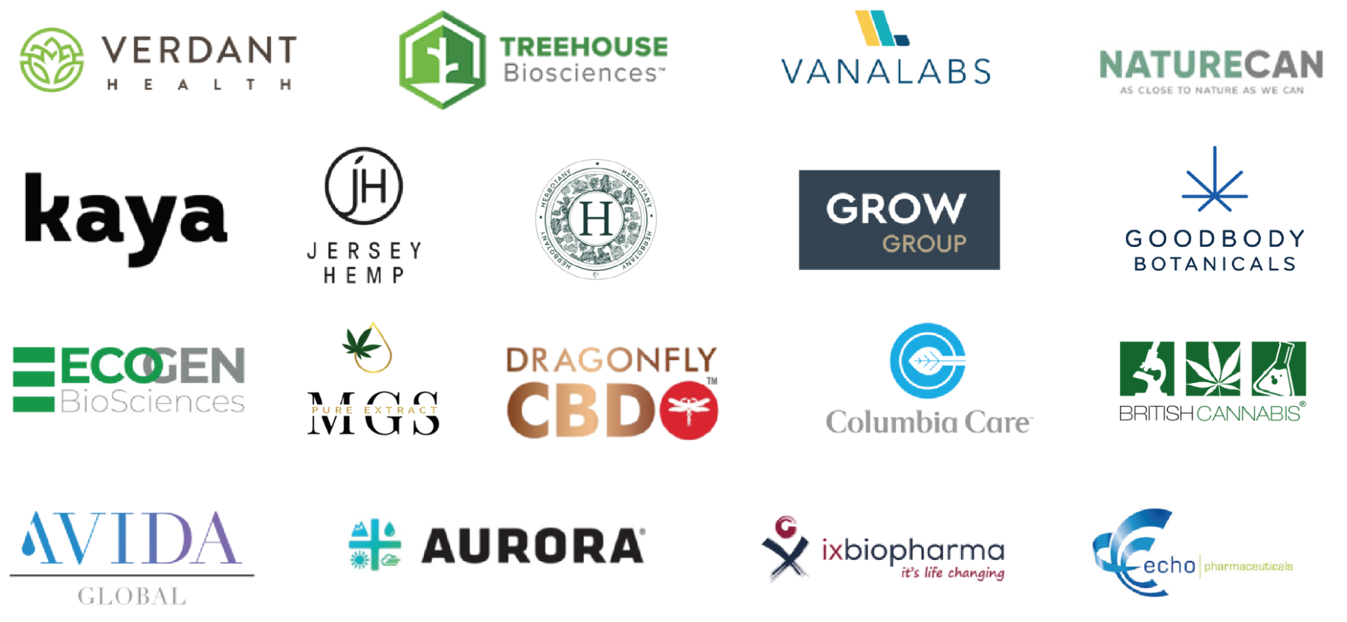

Navigant/Dynata

